2011-2012 Go Red For Women
Partnership Opportunities
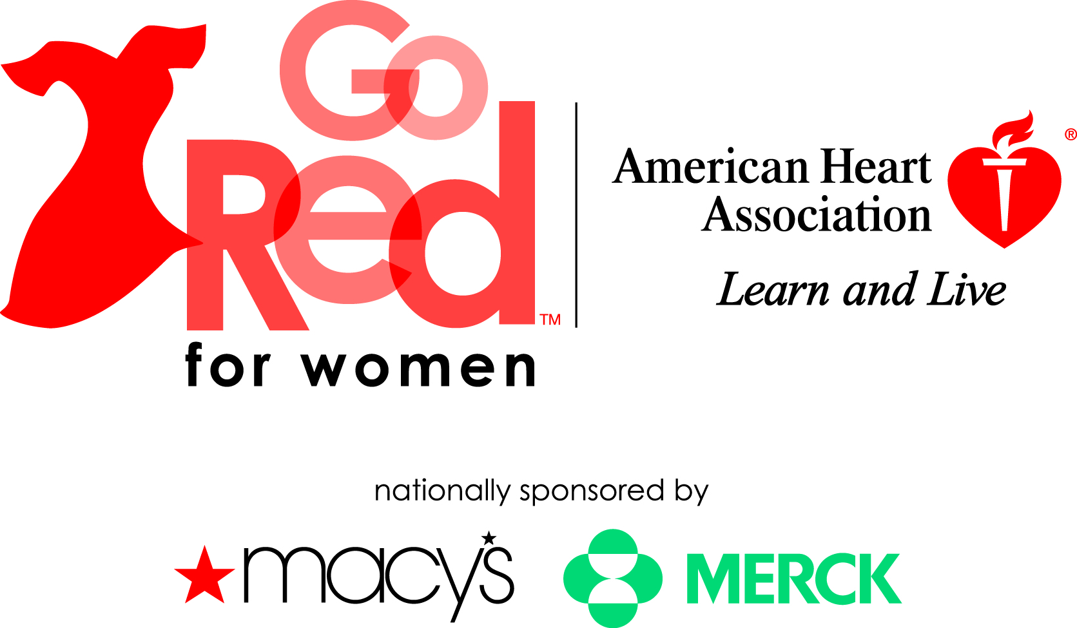

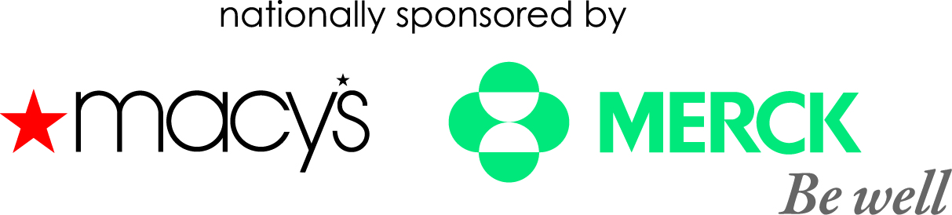

5th Annual Go Red Luncheon and Educational Forum
Sponsored by Time Warner Cable
Thursday, May 10, 2012
Charlotte Convention Center
Chair: Carol Hevey
EVP East Coast Operations Time Warner Cable

Go Red For Women History
In February 2004, the American Heart Association launched Go Red For Women, a nationwide initiative designed to raise women’s awareness of their risk of heart disease, communicate the simplicity of risk reduction and create a compelling call to action that drives women to take control of their health. Go Red For Women provides knowledge and tools to empower women to make positive changes in their lives that may help reduce their risk of heart disease and stroke.

Why Go Red?
Heart disease is the No. 1 killer of women.

- A woman dies every minute from cardiovascular disease, claiming the lives of over 432,000 women every year.
- While 1 in 30 American women die of breast cancer, almost 1 in 3 die from cardiovascular disease.
- 43 million American women are living with cardiovascular disease (CVD).
- Only 57% of American women recognized that heart disease is their leading cause of death.

Components of Go Red For Women
Go Red REGISTRATION: Signing up for the movement includes a monthly e-newsletter filled with heart-healthy tips, plus invitations to events in your area, as well as access to Go Red merchandise, special programs and more.

Heart CheckUp: An online tool that provides a 10-year, personal heart disease risk assessment. Once completed, women take their CheckUp results to their healthcare provider and develop a personal health plan that matches their needs.

Consumer Education: The AHA has compiled materials for consumers such as a cookbook, brochures, wallet cards, bookmarks, posters, Web alerts, screen savers, e-cards, etc.

Physician resources: The American Heart Association works with healthcare professionals to provide new prevention guidelines, patient reports, red dress pins, wallet cards, online monthly newsletters and more.

National Wear Red Day: On the first Friday in February, the AHA encourages women to wear red – whether it is a red dress, a red t-shirt, a red dress pin or red lipstick. Show the world you passionately support Go Red For Women!

Go Red for Women 2012 Partnership
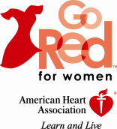
$50,000-Signature Sponsor

Opportunities to leverage your partnership
- Opportunity to be Signature Sponsor day of the event
- Opportunity to speak from the podium day of event
- Opportunity to serve on event committee
- Ability to provide volunteers (experts, survivors, staff, etc.) day of the event (with American Heart Association approval)
- Two (2) tables of ten (10) at luncheon with table signage
- Opportunity to have up to two (2) booths in expo/networking area
- Opportunity to provide promotional item for gift bag (American Heart Association approval required)
- Opportunity to be recognized on local Go Red For Women website with link to company website
- Opportunity to be recognized on local Go Red For Women local Facebook and Twitter sites
- Opportunity for 90-day activation rights to co-brand with Go Red For Women
- All invitations, save the date cards, and collateral material will recognize company as the Signature Sponsor (time sensitive)
- Logo and sponsorship recognition on specific sponsored asset via collateral materials (time sensitive)
- Use of proclaimer statement: “Made possible by”, “Brought to you by”, “Provided by”, “Provided courtesy of”
- Two (2) full pages of recognition in event program
- Acknowledged the day of the event from the podium
- Company will be included in the American Heart and Stroke Champion’s Program, recognizing individuals and corporations giving $10,000 or more
Investment
$50,000

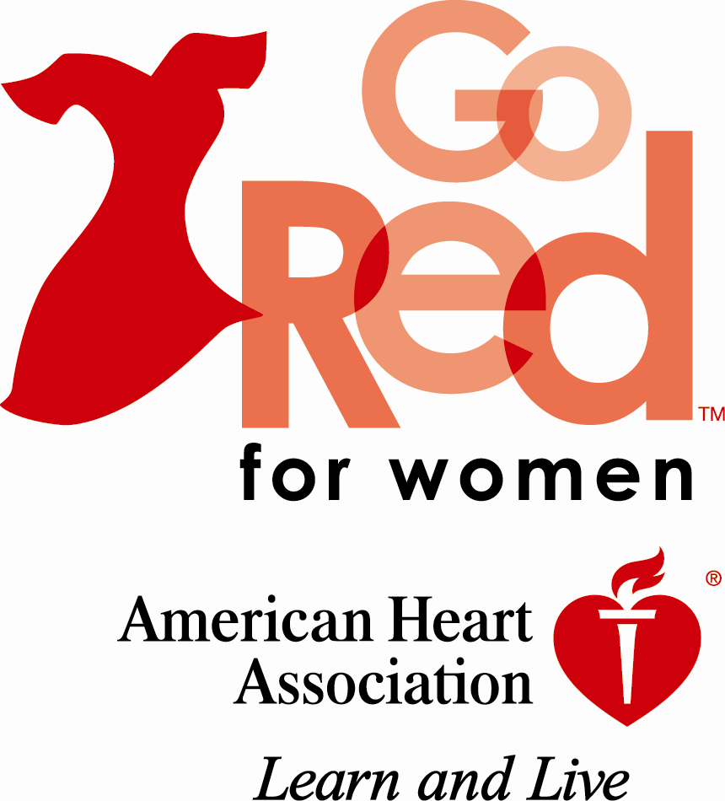
Go Red for Women 2012 Partnership
$25,000 Sponsorship Level - Platinum
Marketing Benefits: CHOOSE ONE
- Go Red Heart to Heart: Host a 30-40min. breakout session on a specific topic at the Go Red For Women Luncheon to give women an opportunity to gather and learn together about fun, consumer-friendly topics relevant to the movement.
- VIP Sponsor: Hold an event prior to the luncheon to bring together local leaders in your community to network and learn about women’s heart health.
- Brown Bag Goes Red: Host luncheon series for employees or an external client to learn about heart health. The American Heart Association will help to coordinate and provide a medical professional speaker at ten company sites.
- *CPR Anytime Sponsor: Increase local survivorship of heart-related emergencies through distribution of CPR self-training kits to targeted audience in the community. Sponsor logo will be present on kits. Insert introduction letter from sponsor to accompany kits. (# of kits is to be determined and paid for by the sponsor).
- Casting Call: Host an opportunity for local women to share their stories of heart disease.
- *Executive Women Breakfast: host a breakfast that brings together executive-level women and other influential individuals to network, share personal stories, and become engaged in the Go Red For Women Movement.
- Picture and a Promise: Host walk-up digital photo-booth at Luncheon and other relevant, year-round events to visually capture women making a commitment to a healthier lifestyle. Opportunity to mail a “heart healthy” message and printed frames with follow-up materials to participants.
- Call to Action- Engage women in the movement by planning recruitment activities with local phone company or cell phone provider; encourage women to call their friends simultaneously, asking them to join the movement. Benefits include: logo/presence on registration cards and signage; PR/media outreach; opportunity to provide incentives to women in attendance and those signing up.
- Survivor Gallery-This unique photo exhibit features local, female heart disease survivors in intimate portraits that feature their compelling stories. This gallery can be displayed as your worksite, at AHA events and travel to other prominent locations around Charlotte.
*Additional fees or expenses may apply

Opportunities to leverage your Partnership
- Ability to provide volunteers (experts, survivors, staff, etc.) for specific sponsored asset (with American Heart Association approval)
- One table of ten (10) at luncheon with table signage
- Opportunity to have up to one (1) booth in expo area
- Opportunity to provide promotional item for gift bag (American Heart Association approval required)
- Opportunity for 30-day activation rights to co-brand with Go Red For Women
- Opportunity to be recognized on local Go Red For Women website with link to company website, Facebook and Twitter sites
- All invitations, save the date cards, and collateral material will recognize your company as a $25,000 contributor
- Logo and sponsorship recognition on specific sponsored asset via collateral materials (time sensitive)
- Use of proclaimer statement: “Made possible by”, “Brought to you by”, “Provided by”, “Provided courtesy of”
- One (1) full page of recognition in event program
- Company will be acknowledged the day of the event from the podium
Investment
$25,000
Go Red for Women 2012 Partnership
$10,000 Sponsorship Level-Gold

Marketing Benefits: CHOOSE ONE
- *Professional Outreach: Promote the movement by providing professional outreach materials to individual healthcare professionals in the community and encouraging them to engage their colleagues.
- *Speakers Bureau: Host a panel of experts on relevant topics to the movement at a special community event held during the months leading up to the Luncheon in May
- *Glitz, Glamour and Girlfriends: Host an evening of fun to bring together local women to educate them further about heart health.
- *Buzz Event: Opportunity to host a buzz event of your choice to promote Go Red For Women
- Eat Your Heart Out Luncheon Meal: Heart-healthy lunch, dessert, and beverages to be provided to luncheon attendees. Signage at each place setting and recipes listed in the event program with “brought to you by” your company.
- Go Red Change Award Sponsor: Nominations for the Go Red Change Award can be submitted by friends, co-workers or relatives, and individuals can also nominate themselves. Recipients will be honored at Go Red For Women Luncheon. Time Sensitive.
- Circle of Red Sponsor: Encourage high level donors to become further engaged in the movement and cultivate additional donations via elite events year-round with access to influential women of Charlotte

*Additional fees or expenses may apply

Opportunities to leverage your Partnership
- Ability to provide volunteers (experts, survivors, staff, etc.) for specific sponsored asset (with American Heart Association approval)
- One (1) table of ten (10) at luncheon with table signage
- Opportunity to have one (1) booth in expo area
- Opportunity to provide promotional item for gift bag (American Heart Association approval required)
- Opportunity to be recognized on local Go Red For Women website
- Opportunity to be recognized on local Go Red For Women local Facebook and Twitter sites
- Logo and sponsorship recognition in event program, and on specific day of event collateral materials (time sensitive)
- Use of proclaimer statement: “Made possible by”, “Brought to you by”, “Provided by”, “Provided courtesy of”
- One (1) half page of recognition in event program
- Company will be included in the American Heart and Stroke Champion’s Program, recognizing individuals and corporations giving $10,000 or more
Investment
$10,000

Go Red for Women 2012 Partnership
$5,000 Sponsorship Level-Silver

Marketing Benefits: CHOOSE ONE
Wellness Opportunity:
- *Brown Bag Luncheon Goes Red: Host luncheon for employees learn about heart health. The American Heart Association will help to coordinate and provide a medical professional speaker.
- *Wellness event: to include health screenings, 30 minute presentation on chosen topic from an expert in the field of cardiovascular health
- *CPR Anytime instruction (kits provided at sponsor’s expense)
OR
Day of Event Opportunity:
- Speak from the Heart Sponsor: Sponsor of the keynote speaker at the Go Red for Women Luncheon with company representative making introduction of keynote speaker
- *Swag Bag Sponsor: Logo sponsored bags will be provided to each guest at the Luncheon and you will have the opportunity to provide one item for each bag.
- AV: Sponsor the audio visual needs during of the breakout sessions, networking/expo area and during the Go Red Luncheon
- Red Hot Pursonality Sponsor: Auction sheets printed with company logo, signage in Boutique area, and mention during live auction portion of event.
- Boutique/Networking Area Sponsor: Signage provided in Boutique area and special table set up in Boutique area.
- Program Sponsor: Branding with company logo on each back cover of program given at event.
- Décor Sponsor: Special table sign in ballroom stating décor provided by company with logo.
- Valet Sponsor: Opportunity to leave an item in each car parked at the event, thank you note left in each car with your company logo, signage at event entrance.
- Sweet Touch Sponsor: Help create lasting memories of the 2012 Greater Charlotte Heart Ball by sponsoring the party favors! Custom tags will be created with your company’s logo and attached to each favor (approximately 300-500)
- VIP Go Red Lounge Sponsor: Sponsor and essentially host all VIPs of the Luncheon in a special VIP Lounge area just for ELT Members, Circle of Red members, top donors and sponsors and other VIPs attending the Luncheon, taking place during the event and Boutique/Networking time.

*Additional fees or expenses may apply
Opportunities to leverage your partnership
- Opportunity to volunteer at the event
- One (1) table of ten (10) at luncheon with table signage
- Opportunity to provide promotional item for gift bag (American Heart Association approval required)
- Logo and sponsorship recognition in day of event program on day of event collateral materials (time sensitive)
- Use of proclaimer statement: “Made possible by”, “Brought to you by”, “Provided by”, “Provided courtesy of”
- Receive a ½ page of recognition in event program
Investment
$5,000
Go Red for Women 2012 Partnership
$3,000 Sponsorship Level-Bronze

Opportunities to leverage your partnership
- Opportunity to volunteer at the event
- One (1) table of ten (10) at luncheon with table signage
- Receive a ¼ page of recognition in event program
- Table Sponsorship recognition in day of event program and on day of event collateral materials (time sensitive)

Investment
$3,000

Chrissy Malinky, Director of Development of Go Red For Women
Office: 704.208.5514 Email: chrissy.malinky@heart.org
Local website: www.heart.org/charlottencgoredluncheon

